Procedure Name

PURPOSE
To assist with recording and reporting on Opex Projects within Enterprise Budgeting (EB) and it the OP Budget ledger.

SCOPE
This procedure applied to the Finance & Regulation team (specifically the Management Accountant) and the Asset Creation team (specifically BM Asset Creation)

INSTRUCTIONS
The Corporate Plan is developed in the latter months of the financial year and during this process the budget is set for the next year’s Opex projects. These projects are aligned with the Pricing Submission where possible and their budget amounts are escalated to the dollars of the day.
The Opex project list is used to input the Opex projects into EB for the relevant financial year at the original amount and then automatically escalated to the dollars of the day.
BM Asset Creation will then allocate the cash flow timing of budget expenditure in EB. This information is then used to journal the budget figures into the OP Ledger with the correct timings.
An XLOne report has been created to lookup the figures in the OP Budget Ledger and compare them to the cash flow figures in EB. This is run every month and if there are significant variances the OP Budget Ledger is updated to ensure accurate budget/actual reporting to the board.

Using Enterprise Budgeting

The current (2018 – 2023) Pricing Submission Project Model is called ‘PROJECT1819’
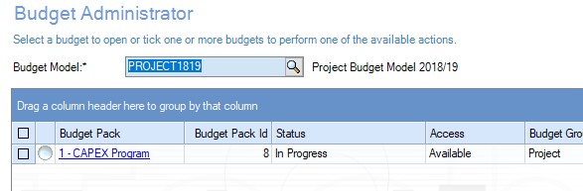

The module is broken into each year of the Pricing Submission in tabs across the top and a separate tab for ‘Escalation Rates’ and ‘Attachments’. The projects are also categorised into Capex and Opex, of which this procedure is focussed on Opex projects only.
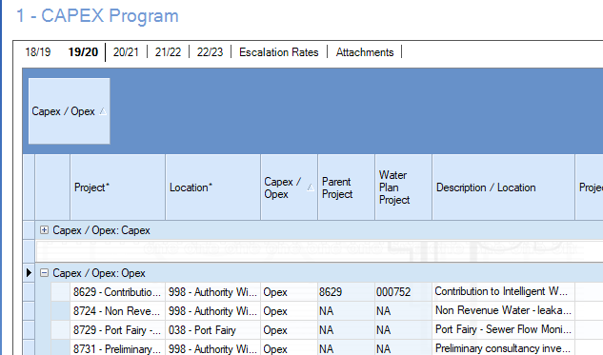

To add a new project:
Steps 1-7 below are only required is the project is not included in any year of the program. If you need to add a project into a new year (project already exists in another year) you can start at step 8.
The following describes the process to add a new project into the model:
- Firstly you need to ensure that the project has been created in both the financial and projects modules.
- Before entering the project into the program (in the year it is required) a new project account needs to be set up.
- To begin this process select the ‘New account’ option

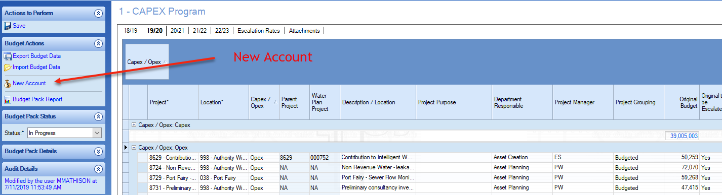

- Now the project account needs to be created. This is done by selecting the project code, the project function and then the location.
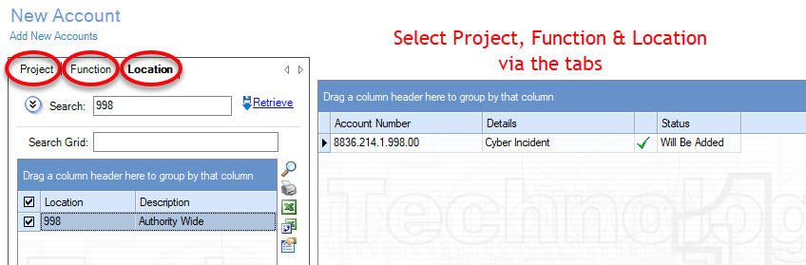
NOTE: ensure that you have the correct function and location for that project by checking in ‘WRW Contract/Project Manager Module. Under ‘Projects List’ tab, search for the project number, click into the project and scroll to the bottom of the details and you will find the financial integration with the allocated function and location.

- If the account has been set up correctly you will see the status displays ‘Will Be Added’.
- If there is more than one project to be added the above steps can be repeated until all new projects accounts have been added. Please note that it is necessary that you note the location code used for each project as this information will be required later in the process.
- Once all new project accounts have been updated you need to select Save. After saving you need to select Retrieve to refresh the data. The projects can now be entered into the worksheet.
- To add a project into the worksheet, ensure that you have the correct year’s tab open. At the bottom of the project list there will be a blank row that you can use to enter new project lines.

- The project number can be typed into the project cell or it can be selected from the drop down list.
- The location code can be typed into the cell or selected form the drop down list.
Please note that the location code MUST match the location code used when creating the project account.
- All other information in the project fields should be completed as appropriate. If the project is being added into a new year and exists already in another year, you need to ensure where relevant the information is consistent.
- Once all of the required information is entered the worksheet should be saved by selecting ‘Save’ under ‘Actions to Perform’ in the top left of the window.

During the year:
Throughout the year new projects will be added for unexpected ‘incidents’ to enable clear tracking of costs. These are ‘Non-Budgeted’ projects and are allocated to the Risk and Resilience team with SVR as the project manager. There may also be wholly externally funded projects that need to be added. We do not record ‘Non-Budgeted’ or ‘Externally Funded’ in the OP budget ledger.

An XLOne report (D2020/063468) has been written to compare the cash flows of the projects in EB with the period’s allocated budget in the OP budget ledger. This report excludes any ‘Non-Budgeted’ and ‘Externally Funded’ projects. This report is run as a part of the end of month process.

Notes:
Before entering the budget amounts into EB at the start of the year ensure that the escalation rate for that year has been updated. It sits at 4.1000 until Simon updates it. This will allow you to ‘de-escalate’ the project amount from the Corporate Plan Opex project list to then make sure that when the amounts in EB are automatically escalated they match the Corporate Plan.

When filling out the ‘Department Responsible’ and ‘Project Manager’ fields, ensure that you don’t make a typo as this information is used by Brad for reporting. Also if you are adding a new ‘Project Manager’ let brad know so he can update his reports.

When monitoring the variances between EB and the ledger ensure that you journal any material timing changes at the end of each quarter. The materiality threshold has not yet been set for this.

RESPONSIBILITY
Management Accountant (Mel Maher): To update all projects at the start of the year and add any new projects during the year. To ensure that the OP Budget Ledger loaded with budgets at the start of the year and the timing is adjusted during the year if required.

MB Asset Creation (Simon Perrin): To allocate the cash flows at the beginning of the year. To monitor the progress of projects during the year and amend cash flows in EB if required.

DEFINITIONS
N/A

DOCUMENTATION
EB and ledger budget comparison XLOne report D2020/063468

REFERENCES
N/A

DOCUMENT CONTROL
 | Procedure Name
Custodian | Management Accountant
Approver | Branch Manager Finance ＆ Regulation
Status | Approved
Version | 1
Approved Date | 11/06/2021
Review Due Date | 11/06/2024

